|  |  |  |  |
| --- | --- | --- | --- |
| **Vertex** | **Visited** | **Weight** | **Prev Vertex** |
| 1 | N | 0 | 0 |
| 2 | N | Inf |  |
| 3 | N | Inf |  |
| 4 | N | Inf |  |
| 5 | N | Inf |  |
| 6 | N | Inf |  |

|  |  |  |  |
| --- | --- | --- | --- |
| **Vertex** | **Visited** | **Weight** | **Prev Vertex** |
| 1 | Y | 0 | 0 |
| 2 | N | 6 | 1 |
| 3 | N | 1 | 1 |
| 4 | N | 5 | 1 |
| 5 | N |  |  |
| 6 | N |  |  |

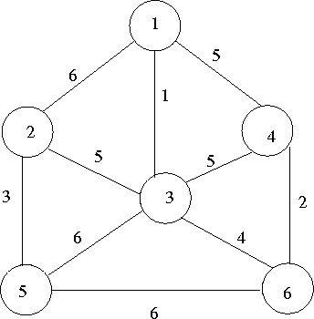

|  |  |  |  |  |  |  |  |  |  |  |  |  |  |  |  |
| --- | --- | --- | --- | --- | --- | --- | --- | --- | --- | --- | --- | --- | --- | --- | --- |
| **Vertex** | **Visited** | **Weight** | **Prev Vertex** | **Vertex** | **Visited** | **Weight** | **Prev Vertex** | **Vertex** | **Visited** | **Weight** | **Prev Vertex** | **Vertex** | **Visited** | **Weight** | **Prev Vertex** |
| **1** | Y | 0 | 0 | 1 | Y | 0 | 0 | 1 | Y | 0 | 0 | 1 | Y | 0 | 0 |
| 2 | N | 5 | 3 | 2 | N | 5 | 3 | 2 | N | 5 | 3 | 2 | Y | 5 | 3 |
| **3** | Y | 1 | 1 | 3 | Y | 1 | 1 | 3 | Y | 1 | 1 | 3 | Y | 1 | 1 |
| 4 | N | 5 | 1 | 4 | N | 2 | 6 | 4 | Y | 2 | 6 | 4 | Y | 2 | 6 |
| 5 | N | 6 | 3 | 5 | N | 6 | 3 | 5 | N | 6 | 3 | 5 | Y | 3 | 2 |
| 6 | N | 4 | 3 | 6 | Y | 4 | 3 | 6 | Y | 4 | 3 | 6 | Y | 4 | 3 |

**Output: Total Cost:15**

**Minimum spanning tree**